Jenkins - 104

=> Global Environment Variables in Jenkins

-> list of jenkins global environment variables: https://www.jenkins.io/doc/book/pipeline/jenkinsfile/#using-environment-variables

-> Way to use global environment variables in jenkins

Step 1: Create a `new item` and item type as `Freestyle project`.

Step 2: Under `Build steps`, select `Execute shell` and write the following commands:

echo “Build number is $BUILD_NUMBER”

echo “Build Id is $BUILD_ID”

echo “Build url is $BUILD_URL”

echo “Job name is $JOB_NAME”

Step 3: Save this jenkins job.

Step 4: Run the jenkins job and observe the logs of it.

-> Way to create and use custom global environment variables

Step 1: Go to `manage jenkins` and then click on `System`

Step 2: Under `Global Properties`, select `Evironment Variables`

Step 3: add a global environment variable

Screenshot:

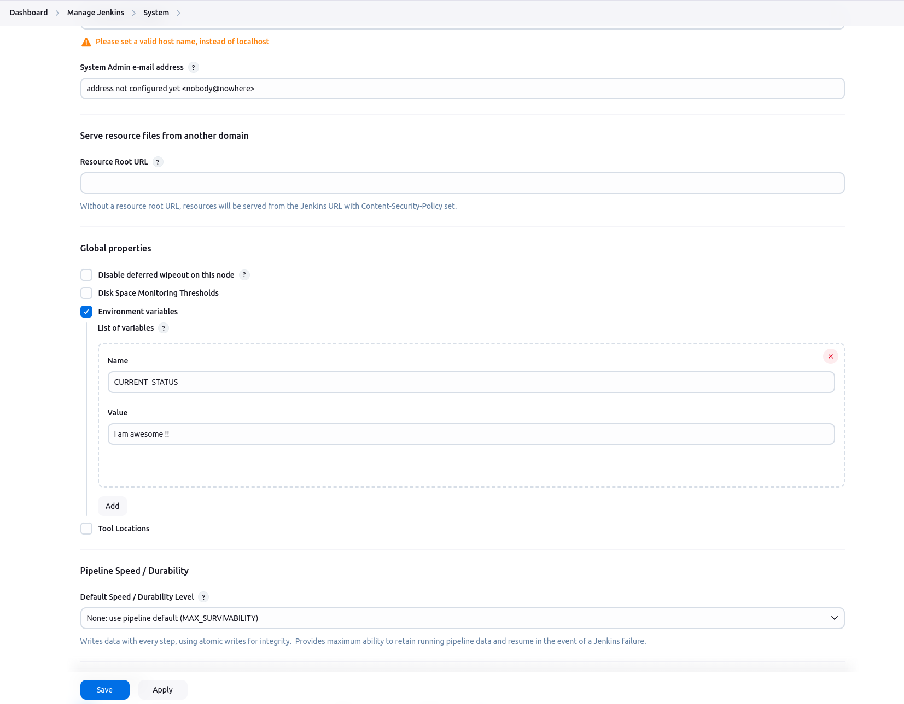

Step 4: Save and again follow the above steps but update the shell commands as follows:

echo “Build number is $BUILD_NUMBER”

echo “Build Id is $BUILD_ID”

echo “Build url is $BUILD_URL”

echo “Job name is $JOB_NAME”

echo “Job current status is $CURRENT_STATUS”

-> Way to execute the jenkins job periodically via cron expression

Step 1: Go to any existing job and click `configure`

Step 2: Under `Build Triggers`, select `Build periodically`

Step 3: Enter the cron expression to periodically trigger the job

Url: [https://crontab.guru/#0_1_*_*_*](https://crontab.guru/#0_1_*_*_*)

Step 4: we want to trigger our jenkins job every day at 1 am. So, enter this cron expression

`0 1 * * *`

Step 5: Save the job

-> Way to trigger the jenkins job externally via a Bash script (Learn on your own, with and without build parameters)